
K.R.MANGALAM UNIVERSITY
WEB PROGRAMMING LAB
COURSE CODE - SEC035
FACULTY NAME- Miss Mansi Kajal
Submitted By- Rashmi Jha
Roll No. -2401010166
Section – B
B.Tech CSE

Experiment 1: Personal Portfolio Development
Aim
To design and develop a basic personal portfolio website by creating a proper folder structure, using semantic HTML for content, applying CSS for a clean layout, and using JavaScript for simple user interaction.
Prerequisites (Languages Used)
- HTML5: Used to build the structure of the page (Header, About, Skills, Projects, and Contact).
- CSS3: Used for styling the page layout, choosing fonts, and setting colors to make the site look professional.
- JavaScript: Used to add interactive features, such as showing a "Thank You" message when a form is submitted.
PROCESS (Implementation)
Task 1: Project Setup & StructureS
A project folder named personal_portfolio was created to organize the source files. Inside the folder, three essential files were developed and linked correctly: index.html, style.css, and script.js.
Task 2, 4, & 6: HTML Structure & Content
The website was built using semantic HTML tags such as <header>, <section>, and <footer> to ensure a clear document structure.
- Header: Contains the name and a short tagline.
- Sections: Includes "About Me", "Skills", "Projects", and "Contact Information".
- Skills: A list displaying at least 3 skills (e.g., HTML, CSS, JavaScript).
- Projects: Two sample projects featuring titles and short descriptions using div containers for organization.
- Contact Form (Bonus): A form containing fields for Name, Email, and Message with a submit button.
Task 3: Styling with CSS
CSS was applied to manage the page layout, spacing, and box model properties like margin and padding. Class and ID selectors were used to ensure the website is visually neat, readable, and properly aligned.
Task 5: JavaScript Interactivity
JavaScript was linked to the HTML to handle DOM manipulation. It captures the form submission to provide a confirmation message to the user without requiring a backend.
Code
<!DOCTYPE html>
<html lang="en">
<head>
<meta charset="UTF-8">
<meta name="viewport" content="width=device-width, initial-scale=1.0">
<title>Rashmi Jha | Portfolio Lab</title>

<style>
* {
margin: 0;
padding: 0;
box-sizing: border-box;
}

body {
font-family: 'Segoe UI', Tahoma, Geneva, Verdana, sans-serif;
line-height: 1.6;
color: #333;
background-color: #f0f2f5;
}

nav {
background: #1a202c;
color: white;
padding: 1rem 5%;
display: flex;
justify-content: space-between;
align-items: center;
position: sticky;
top: 0;
z-index: 1000;
}

nav ul {
display: flex;
list-style: none;
}

nav ul li a {
color: white;
text-decoration: none;
margin-left: 20px;
font-weight: 500;
}

header {
height: 70vh;
display: flex;
flex-direction: column;
justify-content: center;
align-items: center;
background: linear-gradient(135deg, #2d3748 0%, #1a202c 100%);
color: white;
text-align: center;
padding: 20px;
}

section {
padding: 50px 20px;
margin: 30px auto;
max-width: 900px;
background: white;
border-radius: 12px;
border: 1px solid #e2e8f0;
box-shadow: 0 4px 6px rgba(0,0,0,0.05);
}

h2 {
margin-bottom: 20px;
color: #2d3748;
border-bottom: 3px solid #4299e1;
display: inline-block;
}

.skills-list {
display: grid;
grid-template-columns: repeat(auto-fit, minmax(150px, 1fr));
gap: 15px;
list-style: none;
}

.skills-list li {
background: #edf2f7;
padding: 10px;
border-radius: 6px;
text-align: center;
font-weight: bold;
}

.project-grid {
display: flex;
gap: 20px;
margin-top: 20px;
}

.project-card {
background: #fff;
border: 2px solid #edf2f7;
padding: 20px;
border-radius: 8px;
flex: 1;
}

form {
display: flex;
flex-direction: column;
gap: 15px;
}

input, textarea {
width: 100%;
padding: 12px;
border: 1px solid #cbd5e0;
border-radius: 6px;
}

button {
padding: 12px 25px;
background: #4299e1;
color: white;
border: none;
border-radius: 6px;
cursor: pointer;
font-weight: bold;
transition: 0.3s;
}

button:hover {
background: #3182ce;
}

#formFeedback {
margin-top: 10px;
font-weight: bold;
text-align: center;
}

footer {
text-align: center;
padding: 40px;
background: #1a202c;
color: #a0aec0;
}
</style>
</head>
<body>

<nav>
<div class="logo"><strong>Rashmi Jha</strong></div>
<ul>
<li><a href="#home">Home</a></li>
<li><a href="#about">About</a></li>
<li><a href="#skills">Skills</a></li>
<li><a href="#projects">Projects</a></li>
<li><a href="#contact">Contact</a></li>
</ul>
</nav>

<header id="home">
<h1>Welcome to My Portfolio</h1>
<p>B.Tech CSE Student | KR Mangalam University</p>
<br>
<button id="welcomeBtn">Greet Visitor</button>
</header>

<section id="about">
<h2>About Me</h2>
<p>I am a second-year B.Tech CSE student at KRMU. I am passionate about solving complex problems through code and am currently focused on mastering Data Structures and Algorithms for my upcoming Software Development Internship goals.</p>
</section>

<section id="skills">
<h2>Technical Skills</h2>
<ul class="skills-list">
<li>Java & OOP</li>
<li>Python</li>
<li>SQL (Oracle)</li>
<li>HTML/CSS/JS</li>
<li>Azure (AZ-900)</li>
</ul>
</section>

<section id="projects">
<h2>Featured Projects</h2>
<div class="project-grid">
<div class="project-card">
<h3>Student Management System</h3>
<p>Designed a robust system using Java inheritance and interfaces to manage academic records efficiently.</p>
</div>
<div class="project-card">
<h3>100 Days of Code</h3>
<p>A repository documenting my daily problem-solving journey on LeetCode and LinkedIn.</p>
</div>
</div>
</section>

<section id="contact">
<h2>Contact Me</h2>
<form id="contactForm">
<input type="text" id="name" placeholder="Your Name" required>
<input type="email" id="email" placeholder="Your Email" required>
<textarea id="message" rows="4" placeholder="Your Message" required></textarea>
<button type="submit">Submit Message</button>
</form>
<p id="formFeedback"></p>
</section>

<footer>
<p>&copy; 2026 Rashmi Jha | KKMU B.Tech CSE</p>
</footer>

<script>
const welcomeBtn = document.getElementById('welcomeBtn');
welcomeBtn.addEventListener('click', () => {
alert("Thank you for visiting my Experiment-1 Portfolio!");
});

const contactForm = document.getElementById('contactForm');
const feedback = document.getElementById('formFeedback');

contactForm.addEventListener('submit', (e) => {
e.preventDefault();
const nameValue = document.getElementById('name').value;
feedback.innerText = `Thank you, ${nameValue}! Your message has been sent successfully.`;
feedback.style.color = "#38a169";
contactForm.reset();
});
</script>
</body>
</html>
OUTPUT
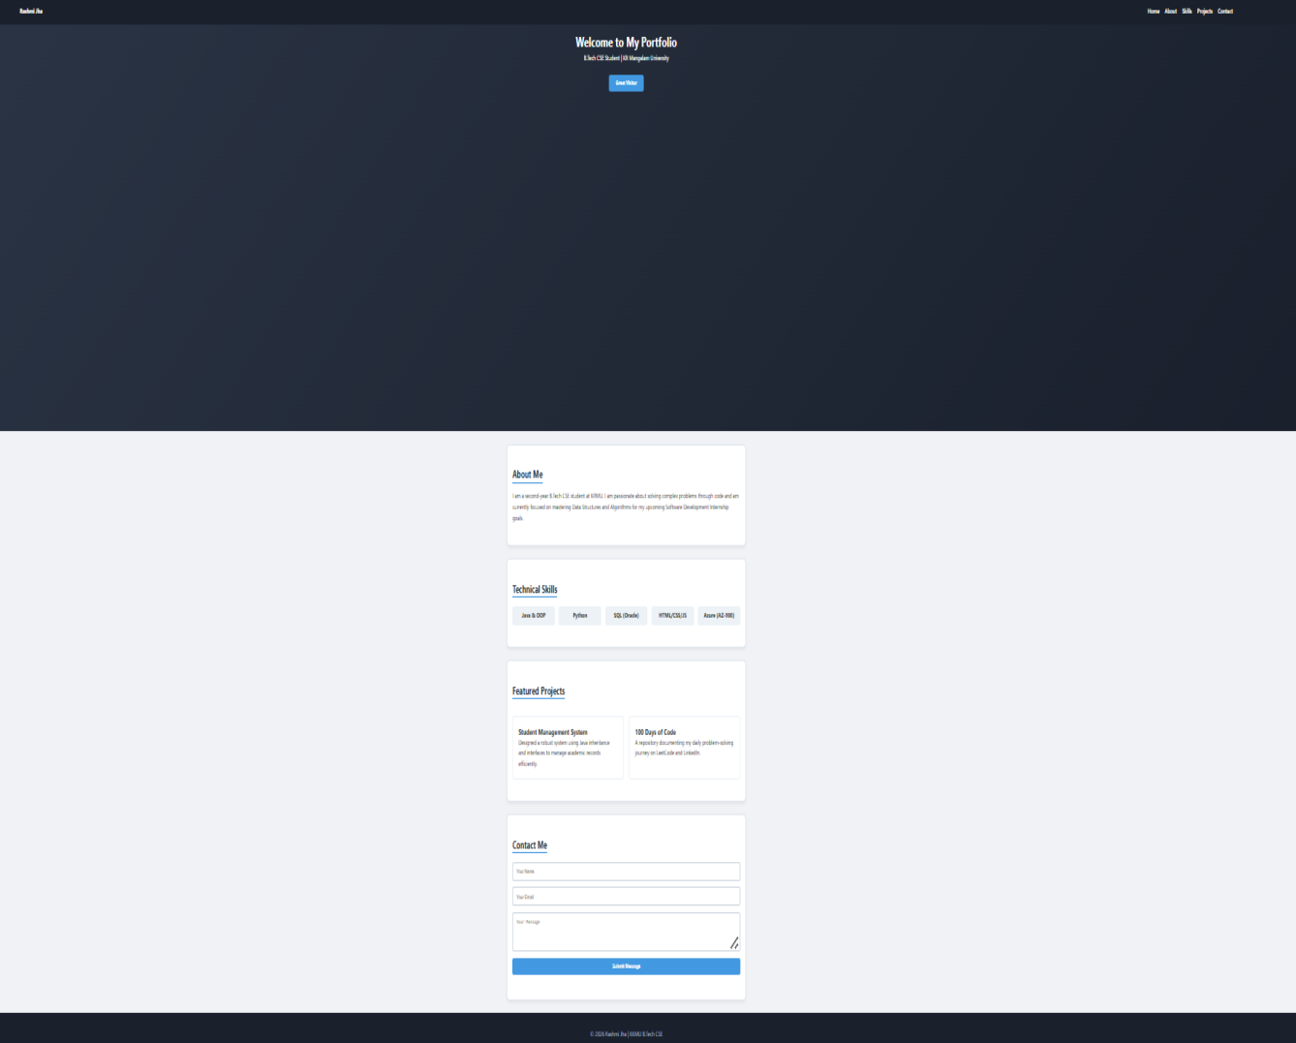

Experiment 2: Company Landing Page Development
Aim
To design and develop a professional landing page for a fictitious company by creating a structured project folder, using semantic HTML for page sections, and applying CSS for consistent styling and layout.
Pre-requisite (Language Used)
- HTML5: Used for the semantic structure of the hero, about, services, testimonials, and contact sections.
- CSS3: Used for professional page layout, background colors, fonts, and box model properties.
PROCESS (Implementation)
Task 1: Project Setup
A project folder named company_landing_page was created. Inside the folder, index.html and style.css were developed and linked correctly to establish the foundation of the site.
Task 2, 4, 5, & 6: HTML Structure & Content
The HTML file was organized into five distinct sections using semantic tags.
- Hero Section: Displays the company name and tagline.
- Services: Lists 3 services using card-style containers for better organization.
- Testimonials: Features feedback from 2 customers.
- Contact Form (Bonus): Includes a simple UI form with Name, Email, and Message fields.
Task 3: CSS Styling
The CSS focuses on section alignment, professional fonts, and the box model (margin and padding) to ensure the landing page is visually neat and readable.
CODE
<!DOCTYPE html>
<html lang="en">
<head>
<meta charset="UTF-8">
<meta name="viewport" content="width=device-width, initial-scale=1.0">
<title>Nova-Tech Creative</title>
<link rel="stylesheet" href="style.css">
</head>
<body>

<header class="hero">
<div class="hero-text">
<h1>NOVA-TECH<span>.</span></h1>
<p>Future-Proof Digital Experiences</p>
</div>
</header>

<section id="about">
<h2>Our Mission</h2>
<p>We are a boutique creative agency specializing in turning complex ideas into simple, elegant digital solutions.</p>
</section>

<section id="services">
<h2>Expertise</h2>
<div class="service-grid">
<div class="glass-card">
<h3>UI Design</h3>
<p>Modern interfaces that keep users engaged.</p>
</div>
<div class="glass-card">
<h3>Dev Engine</h3>
<p>Fast, secure, and scalable web architecture.</p>
</div>
<div class="glass-card">
<h3>Growth</h3>
<p>Digital strategies to scale your business.</p>
</div>
</div>
</section>

<section id="testimonials">
<h2>Client Feedback</h2>
<div class="test-item">
<p>"The design is unlike anything we've seen. Truly unique!"</p>
<strong>- Alex Rivera, CEO</strong>
</div>
<div class="test-item">
<p>"Fast delivery and a stunning final product."</p>
<strong>- Sarah Chen, Founder</strong>
</div>
</section>

<section id="contact">
<h2>Get In Touch</h2>
<div class="contact-box">
<div class="info">
<p>Email: hello@novatech.com</p>
<p>Loc: Innovation Hub, Sector 5</p>
</div>
<form>
<input type="text" placeholder="Name" required>
<input type="email" placeholder="Email" required>
<textarea placeholder="Message" rows="4"></textarea>
<button type="submit">Deploy Message</button>
</form>
</div>
</section>

<footer>
<p>&copy; 2026 Nova-Tech Creative. All rights reserved.</p>
</footer>

</body>
</html>
/* Task 3: Unique CSS Styling */

body {
background-color: #0f172a; /* Midnight Blue */
color: #f8fafc;
font-family: 'Inter', sans-serif;
margin: 0;
padding: 0;
}

/* Hero Section with unique typography */
.hero {
height: 50vh;
display: flex;
justify-content: center;
align-items: center;
text-align: center;
background: linear-gradient(45deg, #1e293b, #0f172a);
}

h1 { font-size: 3.5rem; letter-spacing: -2px; }
h1 span { color: #38bdf8; } /* Neon Blue accent */

/* Task 3: Box Model and Section Alignment */
section {
max-width: 900px;
margin: 40px auto;
padding: 30px;
background: rgba(255, 255, 255, 0.05); /* Glass effect */
border: 1px solid rgba(255, 255, 255, 0.1);
border-radius: 15px;
backdrop-filter: blur(10px); /* Glass blur */
}

h2 { color: #38bdf8; border-bottom: 2px solid #38bdf8; display: inline-block; }

/* Task 4: Service Cards Grid */
.service-grid {
display: flex;
gap: 20px;
margin-top: 20px;
}

.glass-card {
background: rgba(255, 255, 255, 0.03);
padding: 20px;
border-radius: 10px;
flex: 1;
border: 1px solid rgba(255, 255, 255, 0.05);
transition: 0.3s;
}

.glass-card:hover { border-color: #38bdf8; transform: translateY(-5px); }

/* Task 5: Testimonials */
.test-item {
margin-bottom: 20px;
font-style: italic;
background: rgba(56, 189, 248, 0.1);
padding: 15px;
border-radius: 10px;
}

/* Task 6: Simple Form UI */
form { display: flex; flex-direction: column; gap: 10px; }

input, textarea {
background: #1e293b;
border: 1px solid #334155;
color: white;
padding: 12px;
border-radius: 5px;
}

button {
background: #38bdf8;
color: #0f172a;
padding: 12px;
border: none;
border-radius: 5px;
font-weight: bold;
cursor: pointer;
}

footer { text-align: center; padding: 40px; color: #64748b; font-size: 0.9rem; }
OUTPUT
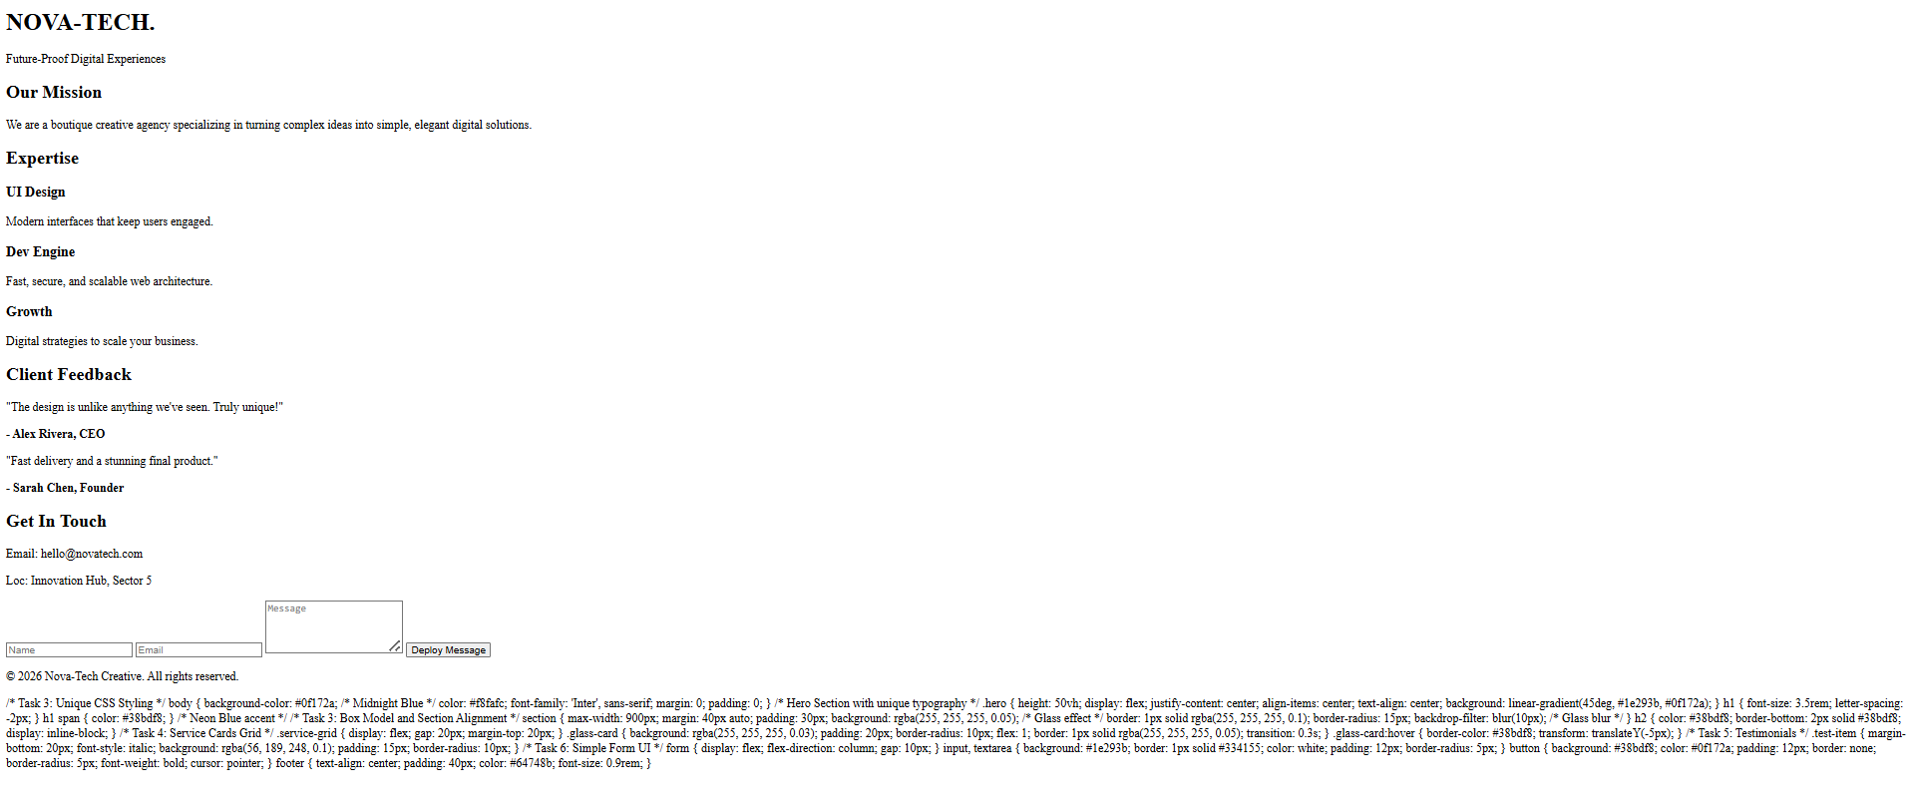
Experiment 3: Interactive Web Development Quiz
Aim
To design and develop an interactive, state-based quiz application using HTML, CSS, and JavaScript that handles dynamic content updates and real-time score calculation.
Pre-requisite (Languages Used)
- HTML5: Used for creating the containerized structure and defining the different states (Start, Quiz, and Result pages).
- CSS3: Used for the dark-themed UI, glassmorphism-inspired containers, and interactive button states (hover and selection).
- JavaScript: Used for managing the logic, including question arrays, score tracking, DOM manipulation for loading questions, and conditional logic for final results.
PROCESS (Implementation)
Task 1: Page Structure & State Management
The HTML is organized into a single container that switches between three distinct views using a .hidden class:
- Start Page: Displays the quiz title and a "Start Quiz" button.
- Quiz Page: Shows the current progress, question text, and dynamically generated option buttons.
- Result Page: Displays the final score and a personalized performance message.
Task 2: Dynamic Content Loading
JavaScript is used to iterate through an array of objects. Each object contains a question string, an array of possible answers, and the index of the correct answer. The load Question() function clears previous options and injects new ones into the DOM for every step of the quiz.

Task 3: Interactive Styling
The CSS provides immediate visual feedback. Option buttons change color when hovered, and the selected class is applied via JavaScript to highlight the user's choice before they confirm their answer.
Code
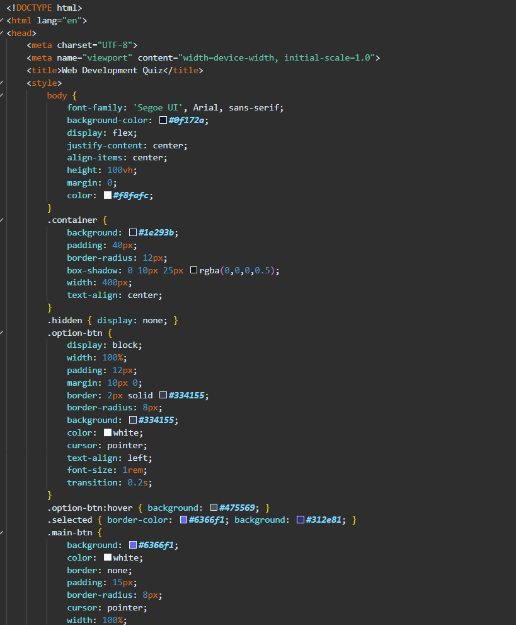
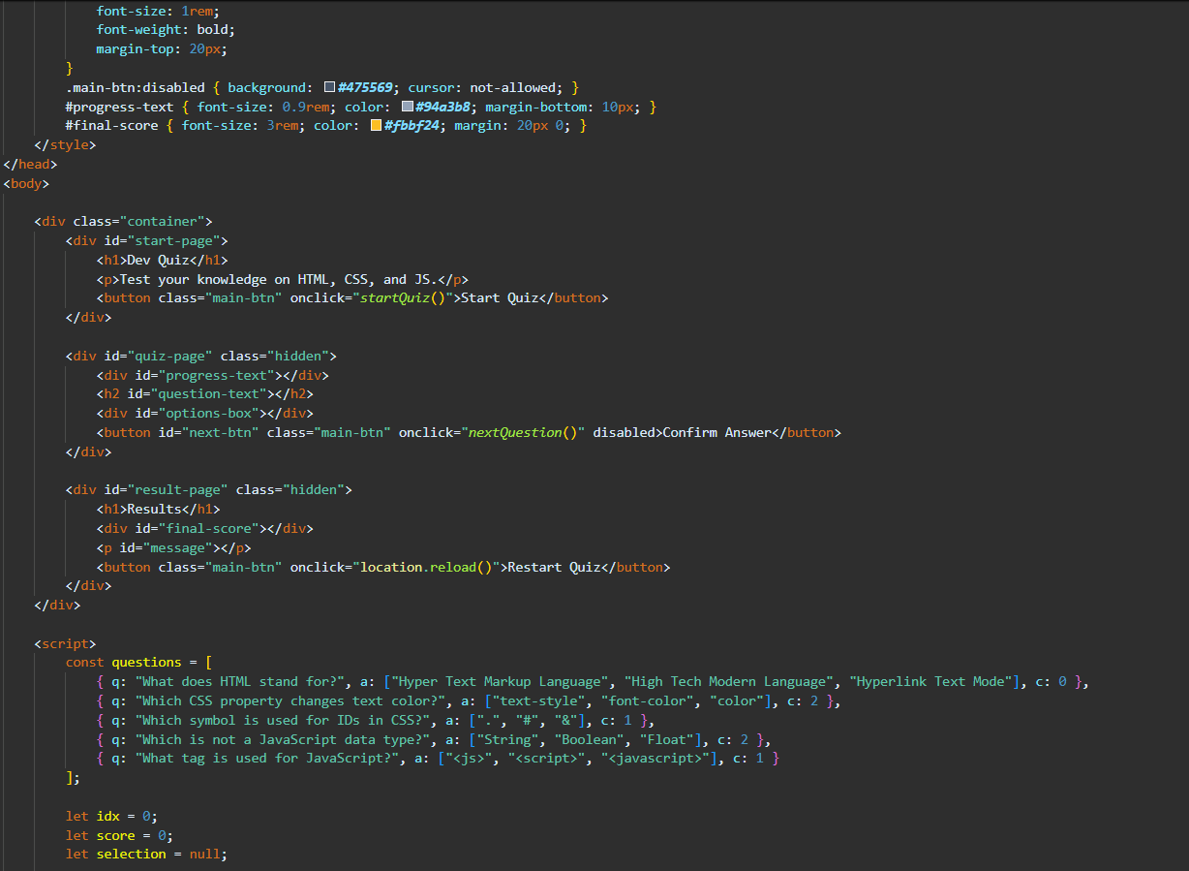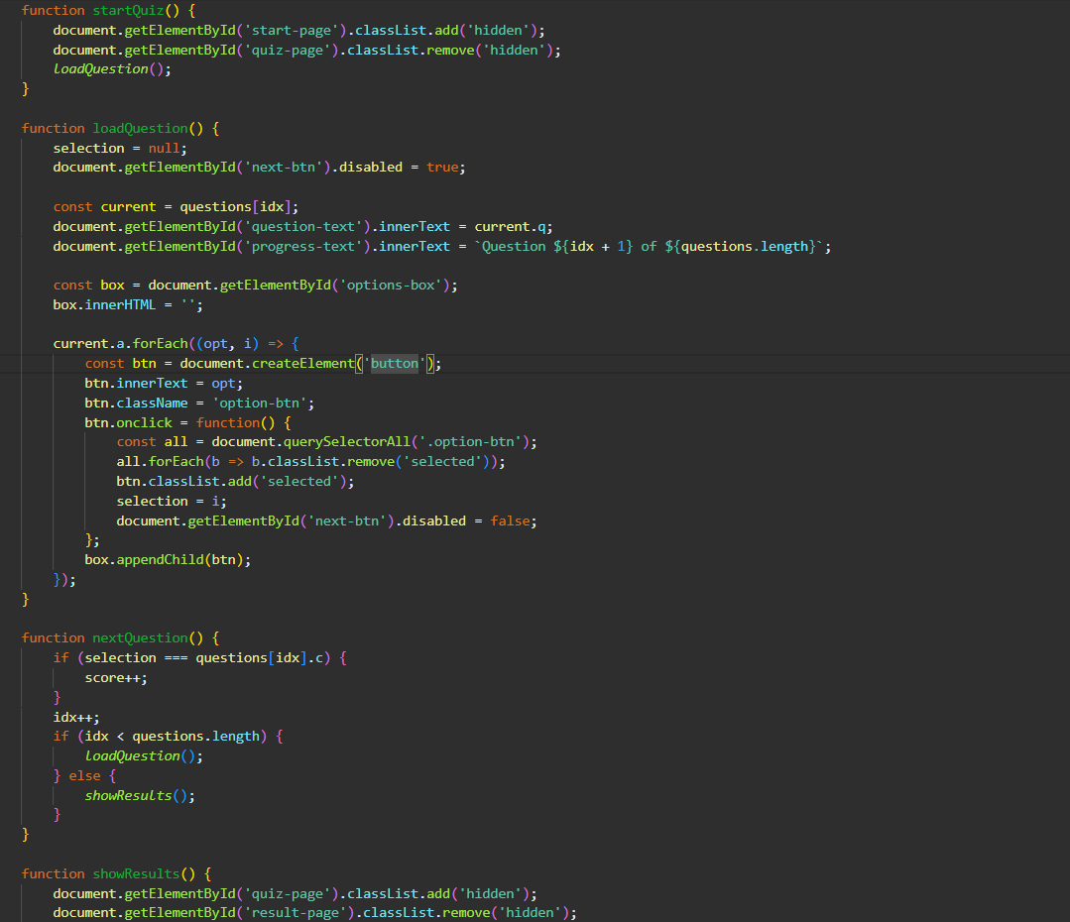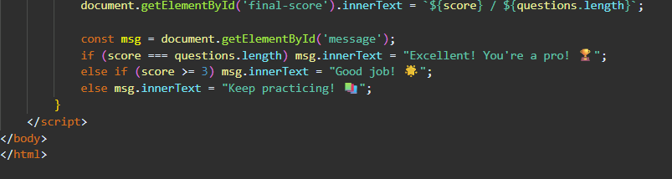
OUTPUT
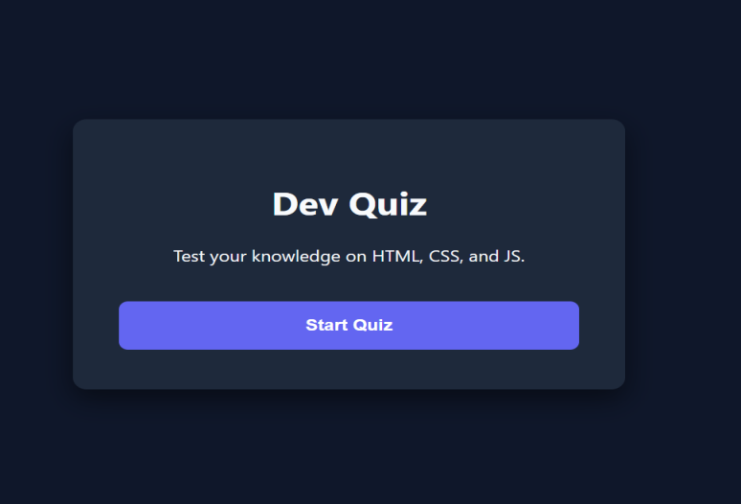
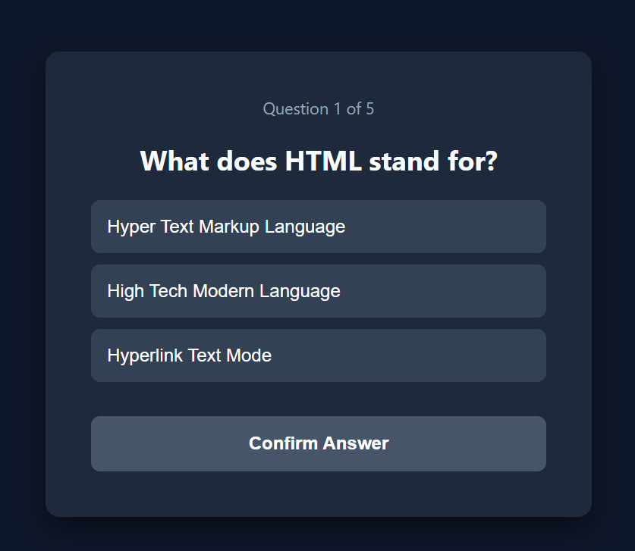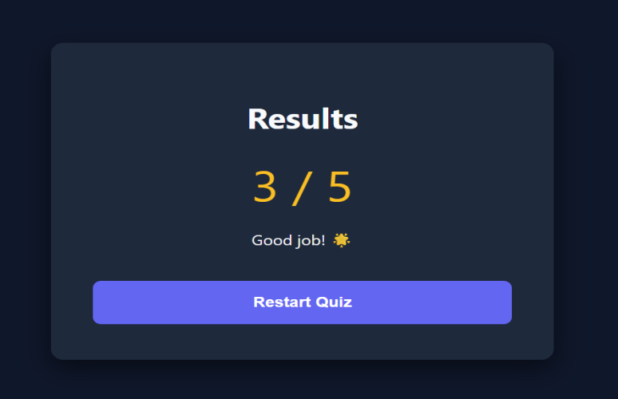
Experiment-4: Dynamic To-Do List

Aim
To design and develop an interactive, state-based task management application using HTML, CSS, and JavaScript that enables real-time CRUD (Create, Read, Update, Delete) operations and dynamic task status tracking.

Pre-requisite (Languages Used)
HTML5: Used for building the application container, input interfaces, and the unordered list structure for task display.
CSS3: Used for the modern dashboard layout, responsive design, and status-based styling (such as strikethrough effects for completed tasks).
JavaScript: Used for event handling, DOM manipulation (creating/removing nodes), capturing timestamps, and managing the logic for real-time pending/completed counters.

PROCESS (Implementation)
Task 1: Dynamic DOM Manipulation The application avoids static list items. Instead, it uses JavaScript's document.createElement() to generate task blocks on the fly. Each block is injected with sub-elements: a checkbox for status, a label for the task text, a timestamp, and action buttons for editing and deletion.
Task 2: State Tracking & Real-Time Counters A centralized refreshApp() function scans the list items within the DOM. It calculates the total number of tasks versus those marked with a "finished" class, updating the UI badges instantly to reflect the current workload.
Task 3: Interactive CRUD Functionality
Create: Captures input and current system time to generate a timestamped task.
Update: Uses a toggle logic for completion status and a prompt() window for text modification.
Delete: Targets the specific parent node of the clicked button to remove the task from the view.

CODE 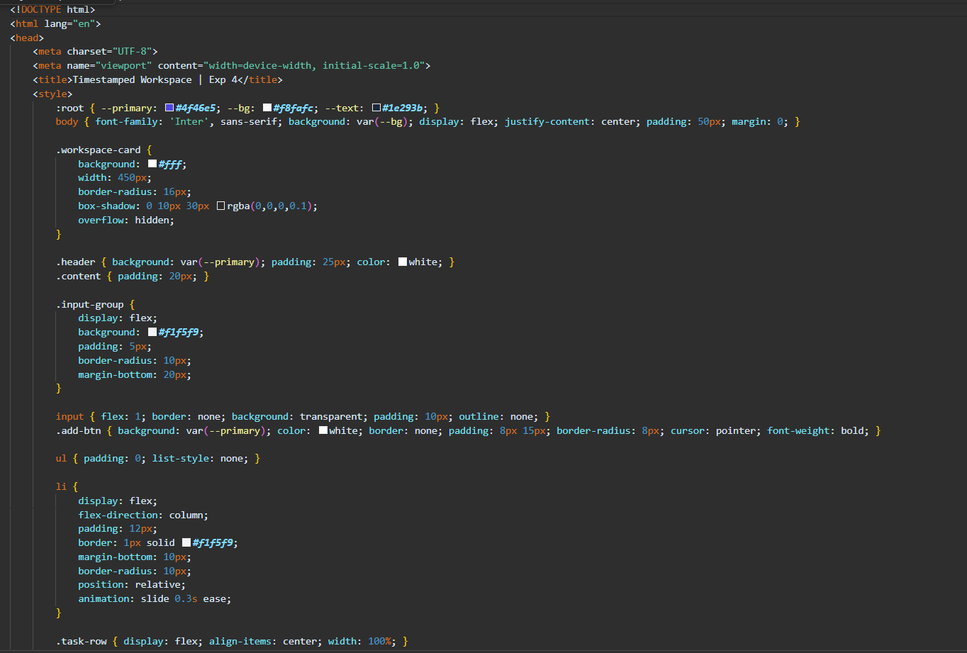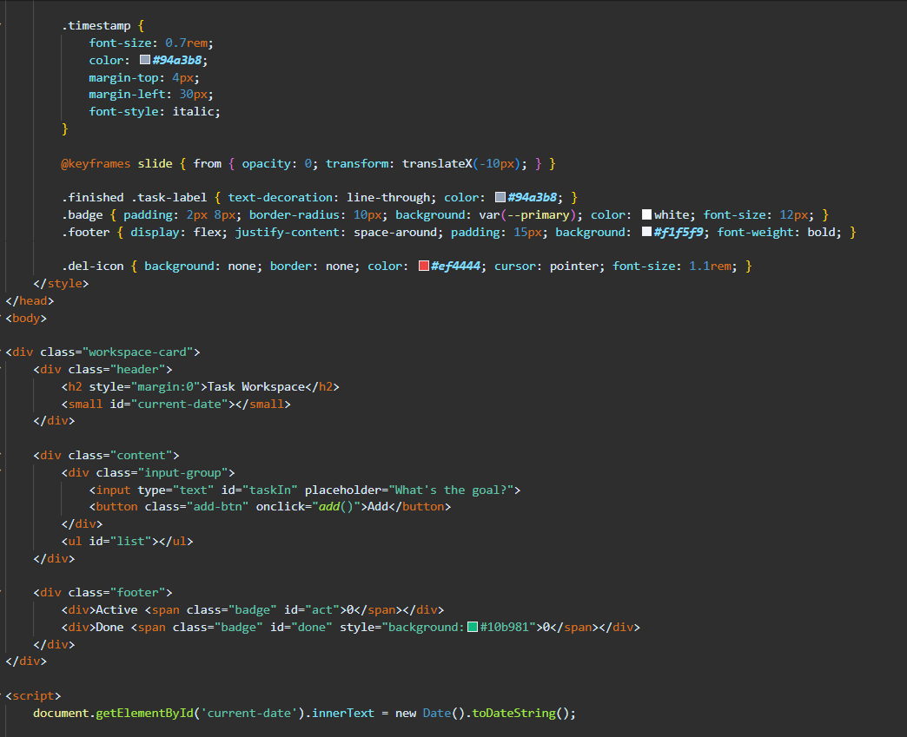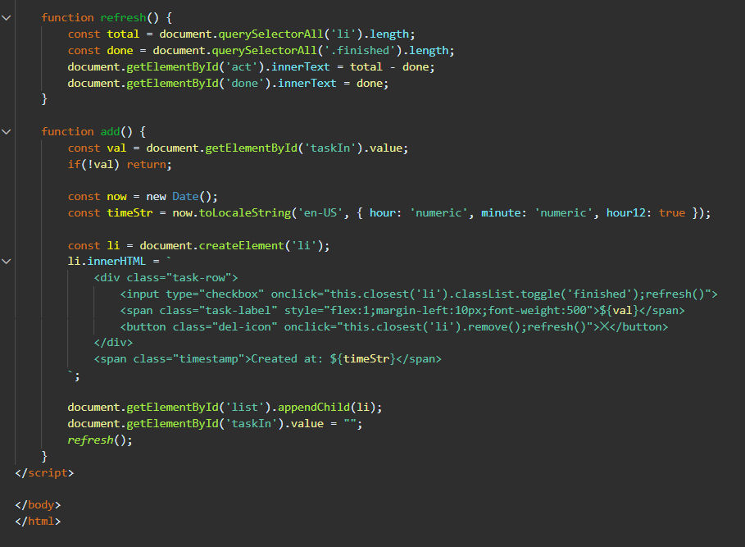

OUTPUT
